ROLL No:241901100
NAME:Sanjay Kumar M
Experiment: 11

EXAMINE NETWORK ADDRESS TRANSLATION(NAT) USING CISCO PACKET TRACER

AIM:
To demonstrate how NAT translates private IP addresses to public IP addresses, enabling private network devices to communicate with external networks. It also includes configuring and verifying different NAT types (Static, Dynamic, and PAT) in Cisco Packet Tracer.
ALGORITHM:
- Build a simple topology with a router connected to a private internal network and an external network.
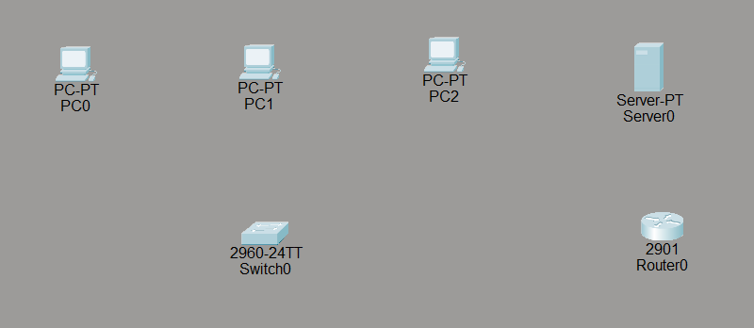
- Assign IP addresses to all devices and router interfaces.
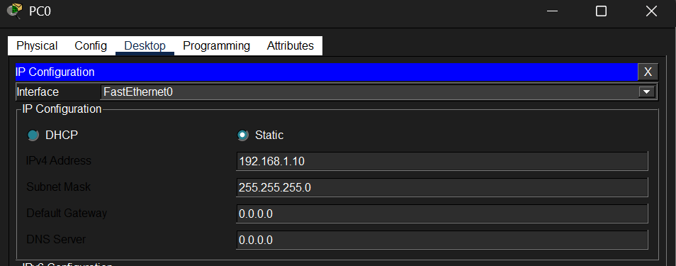
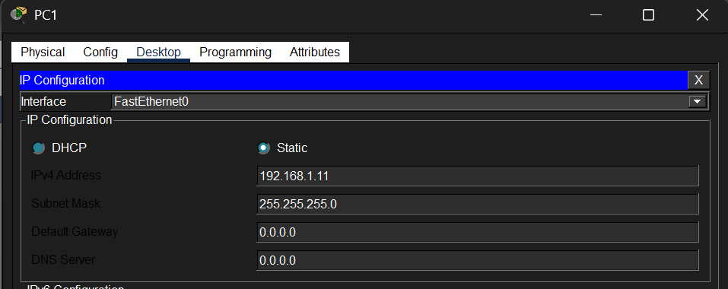
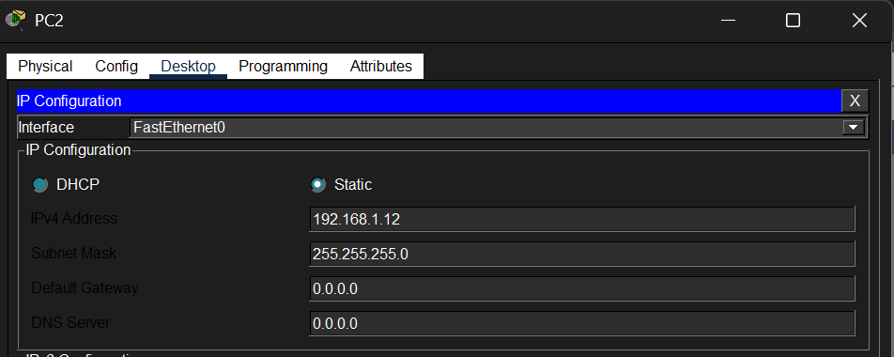
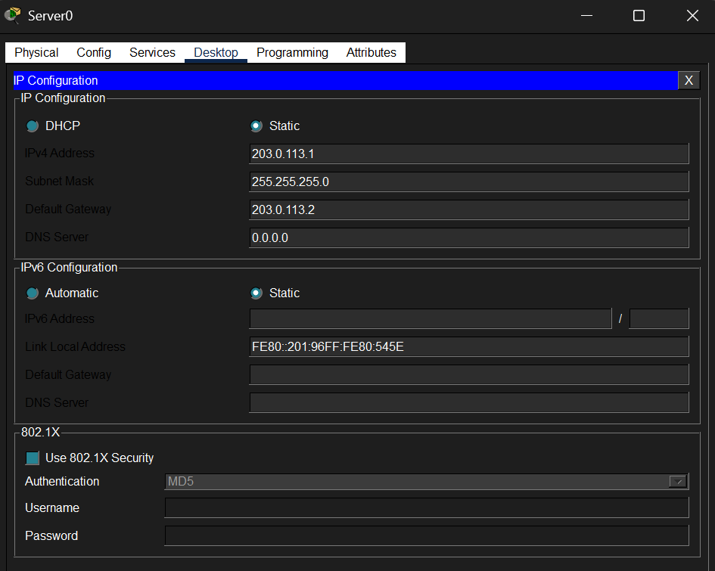
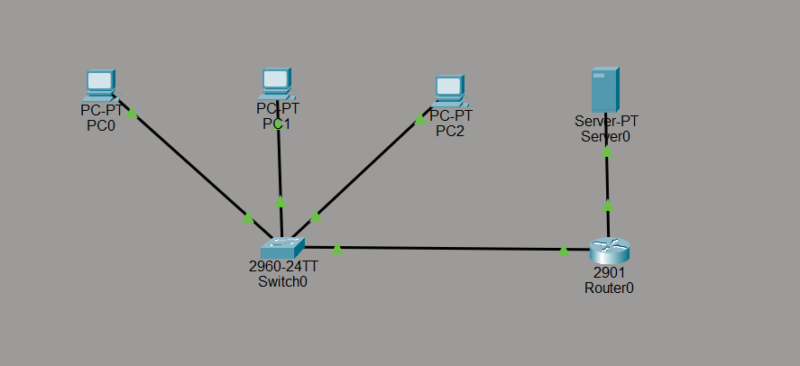
- Configure router interfaces as NAT inside (connected to private network) and NAT outside (connected to external network).
- Define NAT translation rules:
  - Static NAT: Map a specific internal IP to a specific external IP.
  - Dynamic NAT: Use a pool of public IP addresses for translation.
  - PAT (Port Address Translation): Use a single public IP with different port numbers.
- Create access control lists (ACLs) to match private IP addresses allowed to be translated.
- Enable the NAT on the router with the appropriate commands.
- Test connectivity by pinging from inside devices to external devices or servers.
- Verify NAT translation tables using commands like show ip nat translations.

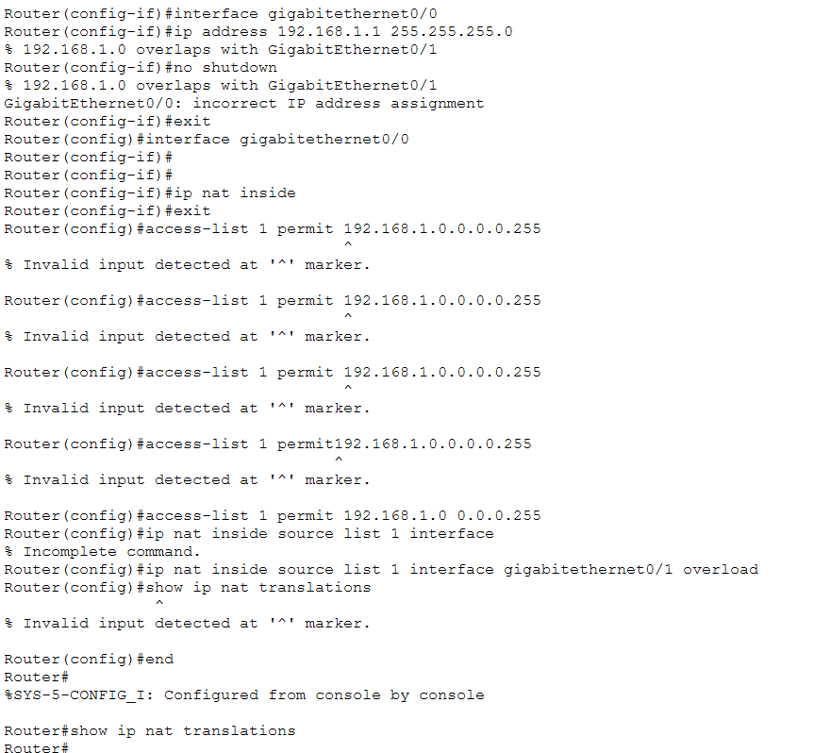
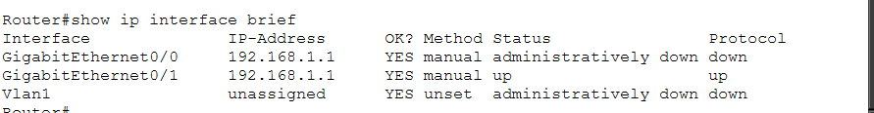
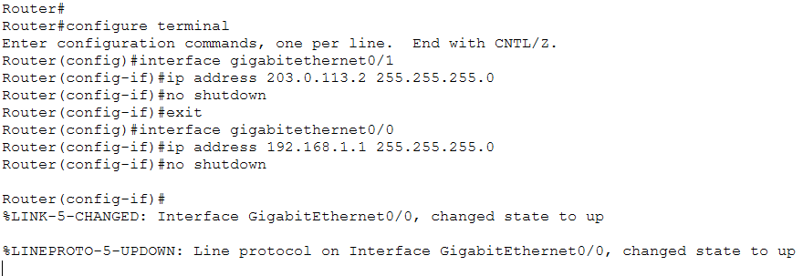

RESULT:
NAT translates private IPs to public IPs for internet access. Routers keep translation tables. NAT enables private devices to communicate externally, verified through Packet Tracer simulations and commands.

